2024 Union JV Festival
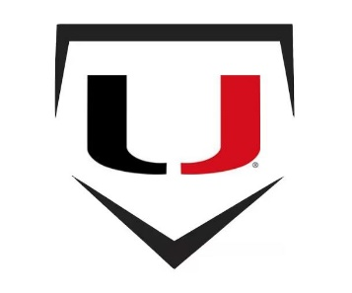
Thursday 4/11/24
10:00 | Collinsville | VS | Bixby White
12:30 | Owasso | VS | BA Black
3:00 | Union Red | VS | Bixby Red
5:30 | Union White | VS | BA Gold

Friday 4/12/24
10:00 | Owasso | VS | Bixby Red
12:30 | Collinsville | VS | BA Gold
3:00 | Union White | VS | Bixby White
5:30 | Union Red | VS | BA Black

Saturday 4/13/24
10:00 | Union Red | VS | Collinsville
12:30 | BA Black | VS | Bixby Red
3:00 | BA Gold | VS | Bixby White
5:30 | Union White | VS | Owasso

Festival Guidelines:
- 2 hour time limit
- Each team provides 1 dozen game balls on first day
- Run Rule: 8 after 5
- 1st team listed will sit in 1st base dugout
- No In/Out on the field
- Cost is $225 per team
- Make checks payable to:
Union Public Schools
Athletic Dept.- UMAC
ATTN: Jaime Harris
6836 S. Mingo Rd.
Tulsa, OK 74133

